Dual PMT Amplifier

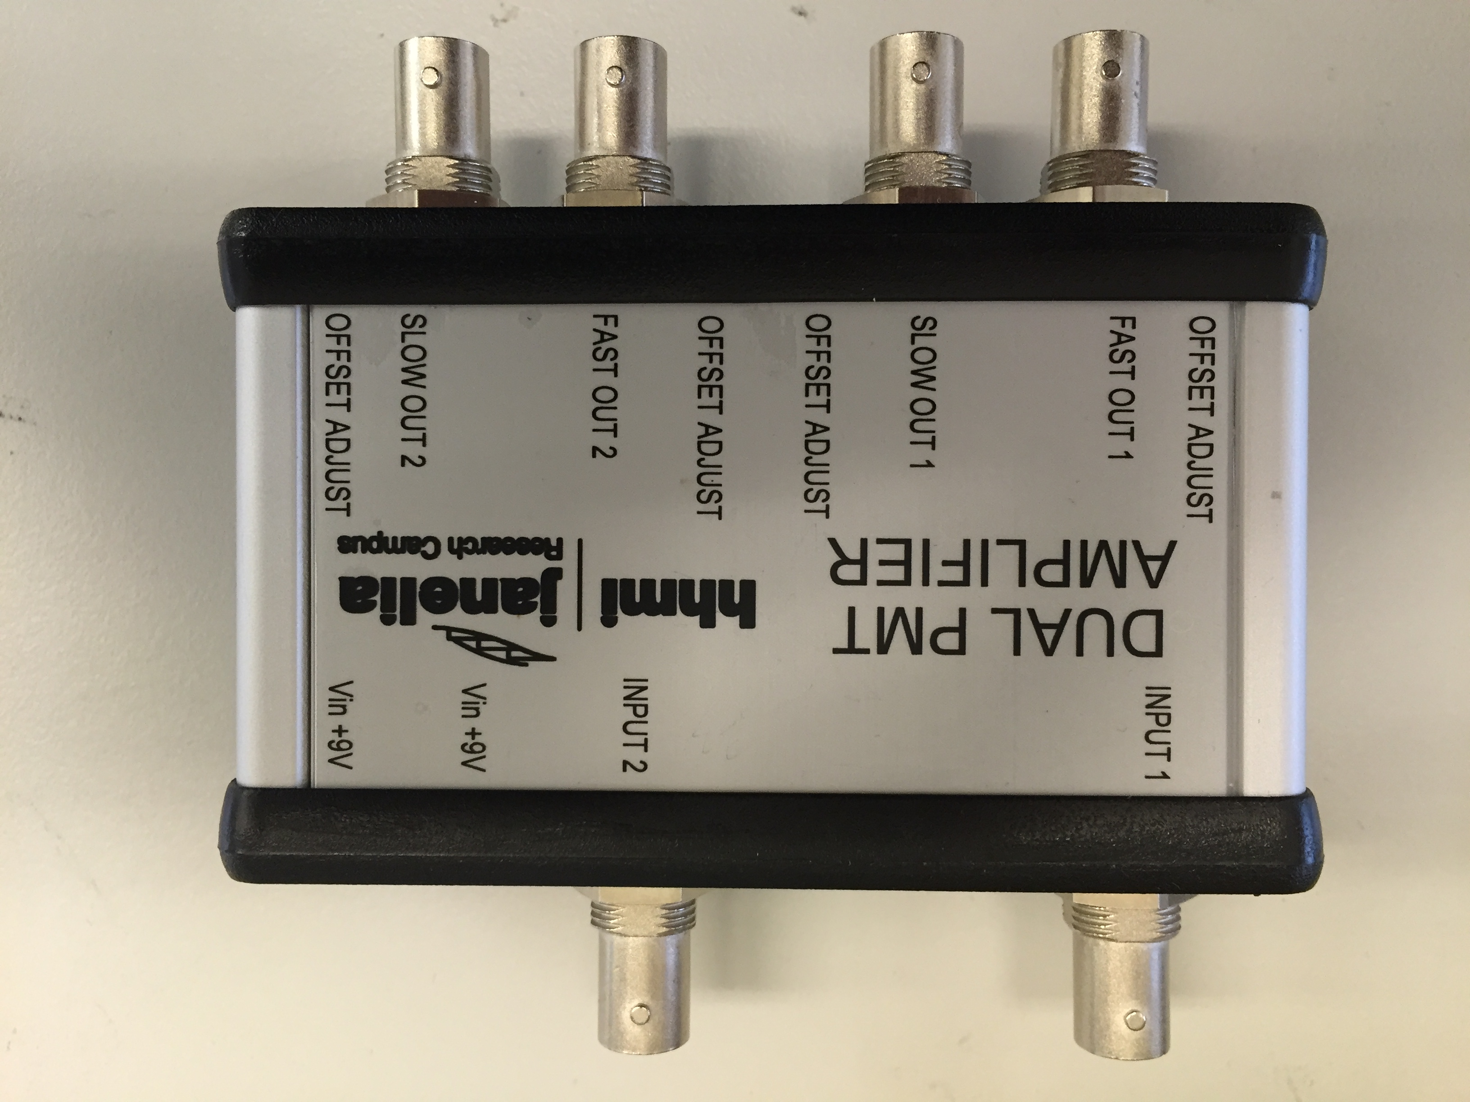

**20150921**

Samantha Watkins

Steve Sawtelle  
 ID&F

# System Overview

The Dual PMT Amplifier is a dual preamplifier for use with Photomultiplier Tubes. It has been specifically designed for applications involving resonant scanning laser scanning microscopy, with pixel dwell times as short as 30 ns. There are fast and slow outputs. The fast output consists of a transimpedance amplifier followed by a buffer. The transimpedance amplifier, feedback resistor (RF) and feedback capacitors together determine the bandwidth and gain of the amplifier. In this document we show two configurations typically used for resonant scanning laser scanning microscopy.

Provision is made for adjusting the offset. The slow output applies a low-pass filter with a 1 kHz roll off to the fast output. The slow output can be used to drive a safety shutdown due to too long light exposure to the PMT.

# Hardware Development

The circuit was set up to allow a variety of amplifiers and topologies to be used so that the design could be tailored to specific needs. Provision is made for an input resistor and feedback capacitance on the input stage. The output buffer can be assembled with offset adjustment if desired. A voltage offset can be applied to the input stage to maximize the voltage swing capability. A jumper can be used to bypass this feature and set the offset to 0 volts.

Power is provided by two wall transformers with voltages in the range of 9 to 12 VDC. The power supplies must be floating as one supply is wired in reverse to provide the negative supply. 5V linear regulators provide stable supplies of the correct voltages and reduce any noise from the power supplies. It is recommended that linear power supplies be used, though switching supplies may be adequate.

The fast output has a 50 ohm series resistor to provide matching to 50 ohm cables. The cables should be terminated with 50 ohms at the other end to remove possible ringing on the signal from mismatched impedances. The output buffer can be set to a gain of 2 to compensate for the halving of the signal due to impedance matching.

The printed circuit board design allows the board to be cut in half to create two separate single channel amplifiers.

The board is designed to fit into a commercially available enclosure manufactured by Hammond Manufacturing: 1455N1201.

# Testing

The PMT Amplifier can be tested with a signal generator when RIN is replaced with a high value resistor. A PMT can also be used to test the Amplifier when a 0Ω resistor is used for RIN. The fast output should display a light pulse from the PMT and the slow output should give a low pass response when the PMT is exposed to too much light.

NOTE: Tests shown were done with an earlier, single channel version of the amplifier. The circuit of the new amplifier is identical and should show equivalent performance.

## Board Configurations

### OPA657-OPA692-OP400, SN: 006 w/ 50 ohm

|  |  |
| --- | --- |
| **Stage 1: OPA657** |  |
| Transimpedance Gain Resistor (RF) | 10 kΩ |
| Feedback Capacitor | 0.4 pF |
| **Stage 2: OPA692** |  |
| Gain | 2 |
| Pulse Duration | 40 ns |
| Output Voltage Offset Adjust | Disabled. Pin grounded to allow for int. gain of 2 |
| **Stage 3: OP400** |  |
| Gain | 1 |
| Filter Cutoff – Freq Response | 1.6 kHz |
| Output Voltage Offset Adjust | Enabled |

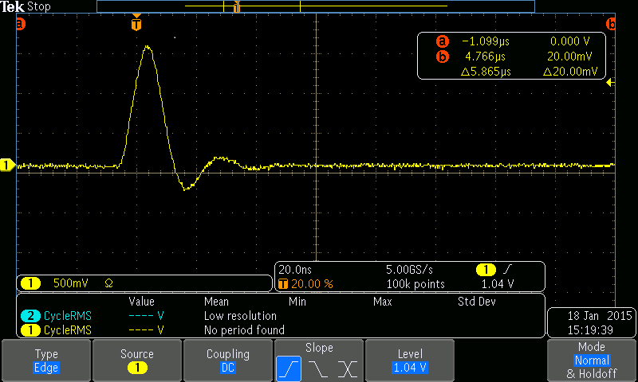



### OPA657-OPA692-OP400, SN: 026 w/ 50 ohm

|  |  |
| --- | --- |
| **Stage 1: OPA657** |  |
| Transimpedance Gain Resistor (RF) | 4.99kΩ |
| Feedback Capacitor | 0.4 pF |
| **Stage 2: OPA692** |  |
| Gain | 2 |
| Pulse Duration | 40 ns |
| Output Voltage Offset Adjust | Disabled. Pin grounded to allow for int. gain of 2 |
| **Stage 3: OP400** |  |
| Gain | 1 |
| Filter Cutoff – Freq Response | 1.6 kHz |
| Output Voltage Offset Adjust | Enabled |

